YORK RI BC OPEN TRIPLES 2020 - RESULTS

MAIN COMPETITION FINALISTS

WINNERS: HAXBY ROAD ROCKETS (Gary Bunce, Jan Suchecki, Mal Lewars)
RUNNERS-UP: JACKO’S REJECTS (Gary Lewington, Graham Bell, John Crowe)

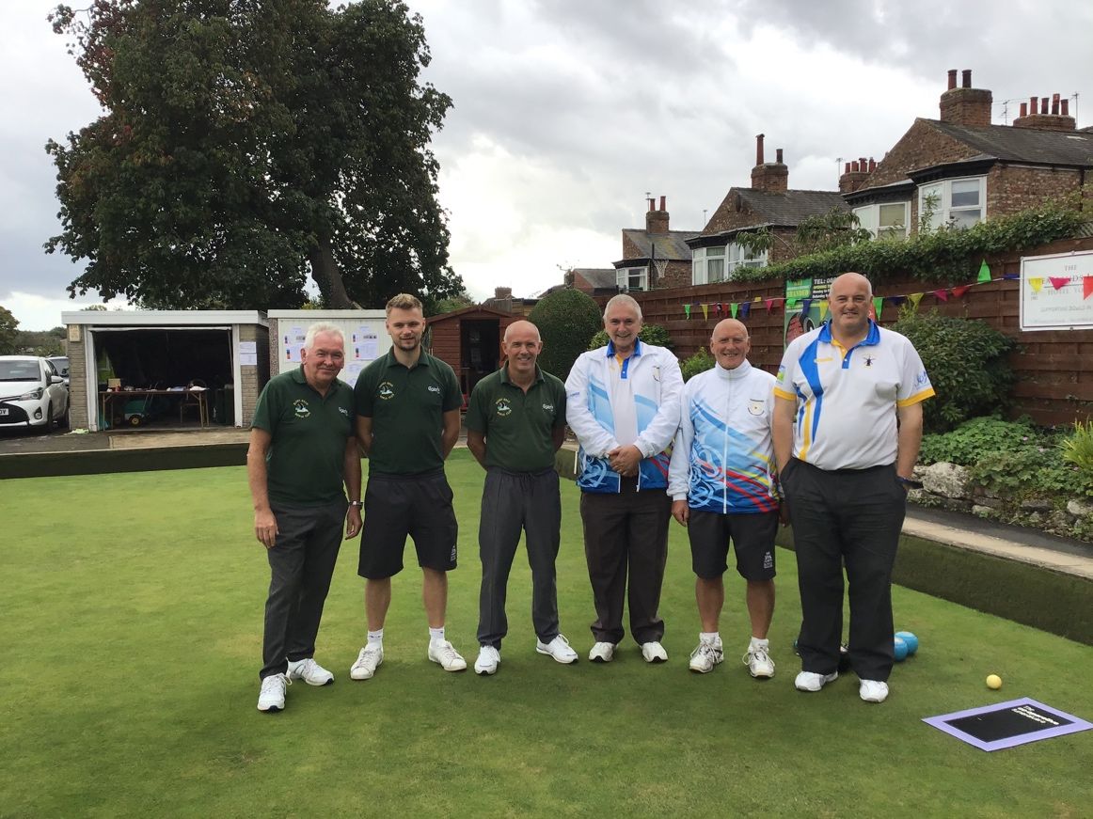

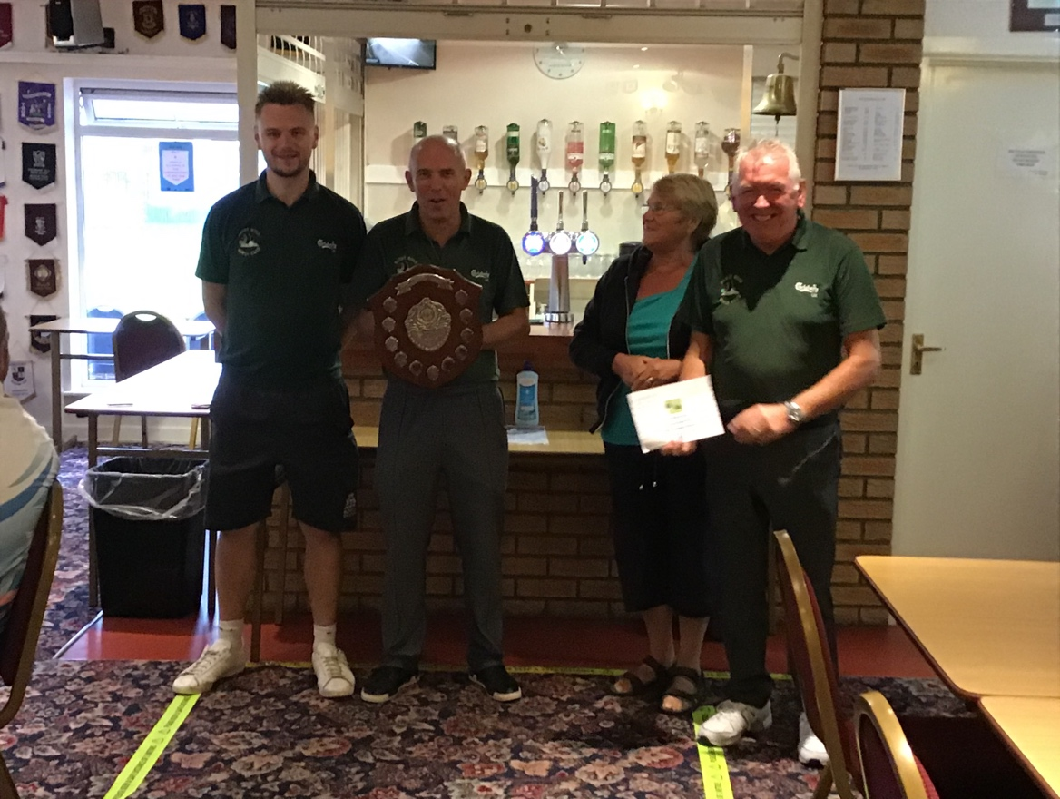

PLATE COMPETITION FINALISTS

WINNERS: THE LAST MINUTES (Mick O’Donnell, Luke Edwards, Nigel Spence)
RUNNERS-UP: CORAM BOY’S (Andy Brookes, Nigel McDonald and Steve Atkinson)

