YORK RI BOWLING CLUB
THE ERIC WILKINSON OPEN TRIPLES
SUNDAY 4 SEPTEMBER 2016

WINNERS
MAL BULMER, DEN SANDERSON, DAVE PREECE
BULLIES BOYS (York RI Corinthians)
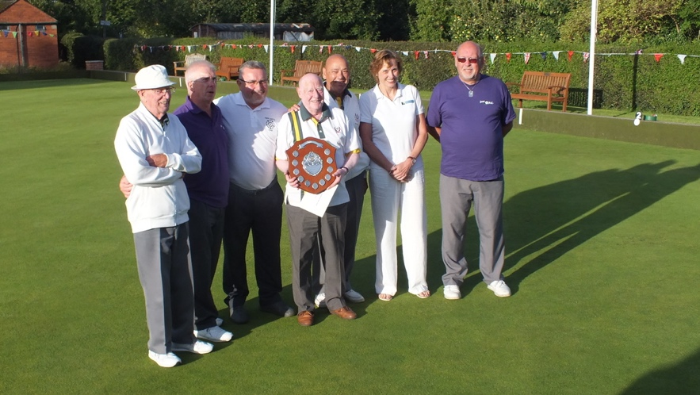

RUNNERS UP
PETE JACKSON, JOHN CROWE, PHIL REEVES
SMOKING BULLETS (Holgate WMC)
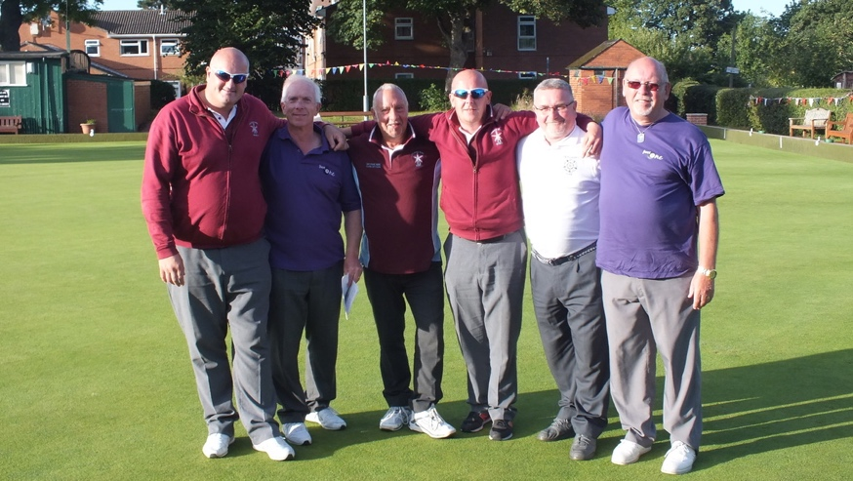

PLATE COMPETITION WINNERS
PETE SMITH, TERRY WHEATLEY, JOHN HOLTBY
THE NON-DRINKERS! (York RI/Scarcroft)
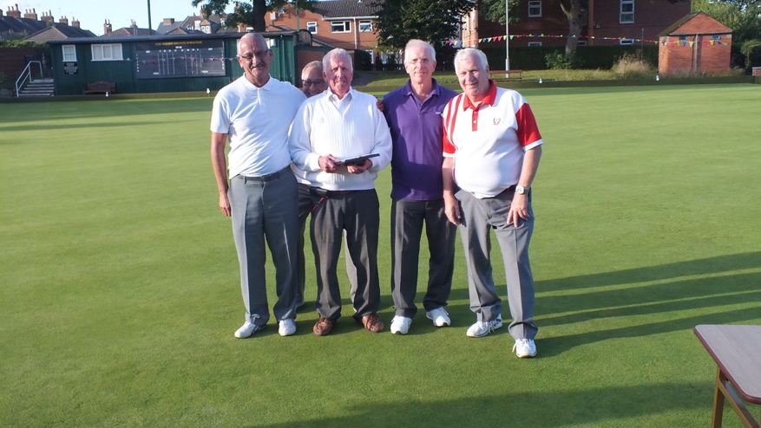

PLATE COMPETITION RUNNERS UP
LINDON WILSON, RUBY ROUNDING, MIKE DAWSON
THE YOUNG ONES (Thornton Le Dale)
