YORK R I BOWLING CLUB
TWO WOOD OPEN TRIPLES TOURNAMENT
SUNDAY 31 AUGUST 2014
WINNERS
COLIN WALLACE, CRAIG WATSON & DENNIS McKEOWN
JACK HATFIELD BC, MIDDLESBROUGH
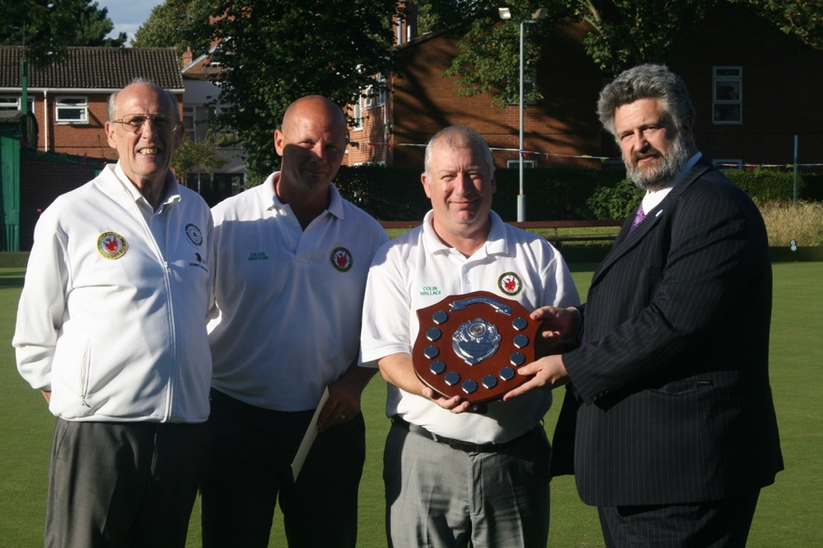,
RUNNERS UP
TEX STEVENS, KEN ROBINSON & NIGEL MACDONALD,
HOLGATE BC

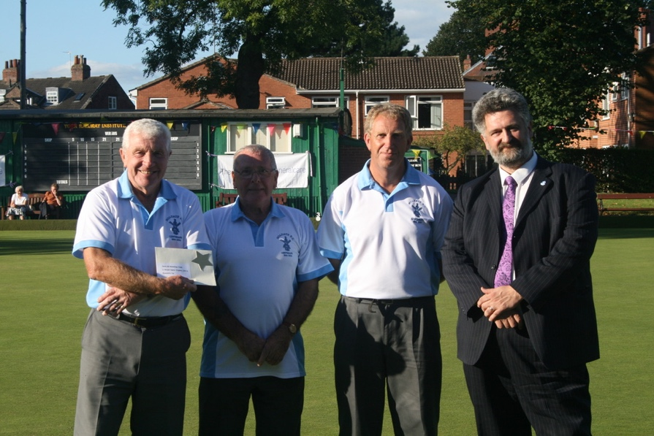

PLATE COMPETITION WINNERS
PAT FLANNERY, PETE RILEY & PETE GODWIN
YORK RI CORINTHIANS BC

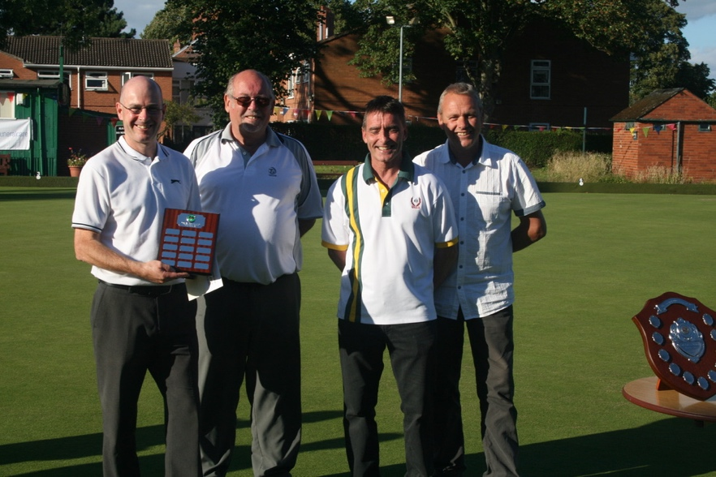

PLATE COMPETITION RUNNERS UP
DAVE NEWSOME, JOSEPH NEWSOME & JILL NEWSOME
NORTH DUFFIELD BC
