THE ERIC WILKINSON OPEN TRIPLES 2019 - RESULTS

MAIN COMPETITION

WINNERS

THE FLAT EARTH SOCIETY GLOBETROTTERS (Mick O’Donnell, Dave Horsley, Luke Edwards)

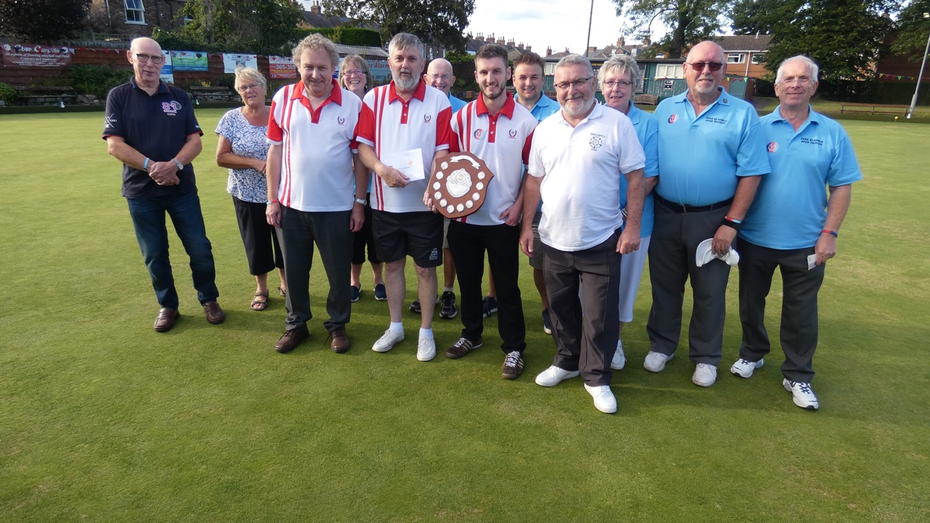

RUNNERS-UP

THE WICK-A- WOO MEN (Alan Phillips, Wayne Phillips, Andy Bailey)

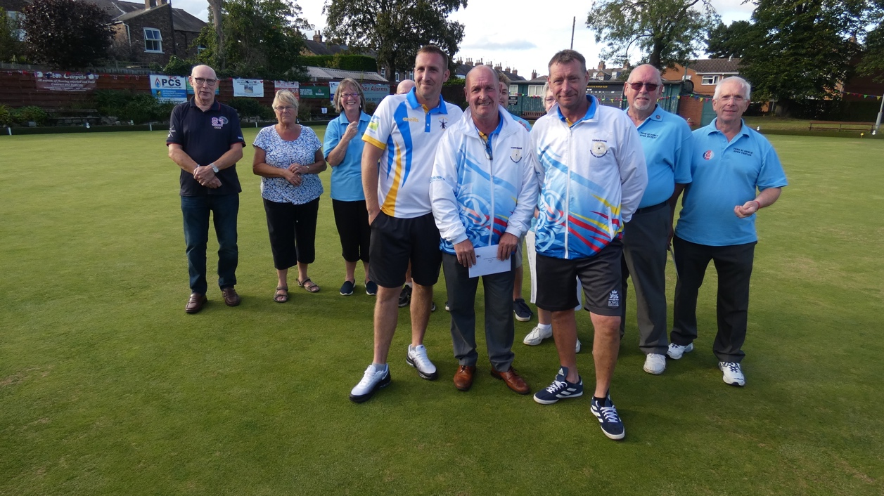
PLATE COMPETITION

WINNERS

THE THREE P’S (Pat Flannery, Pete Godwin, Pete Riley)

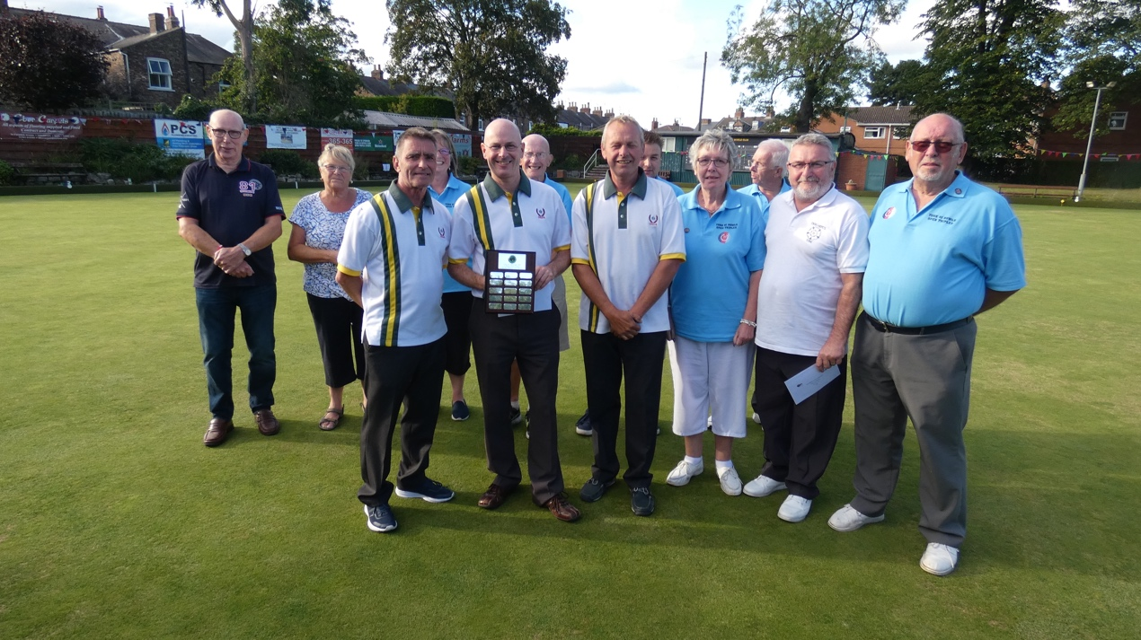

RUNNERS-UP

EBOR CARPETS (Geoff Walker, Kirk Jackson, Adam Jackson)

