THE ERIC WILKINSON OPEN TRIPLES 2018 - RESULTS

MAIN COMPETITION

WINNERS

TONY’S MARVELS (Tony Horobin, Kieran Earnshaw, Craig Newton)

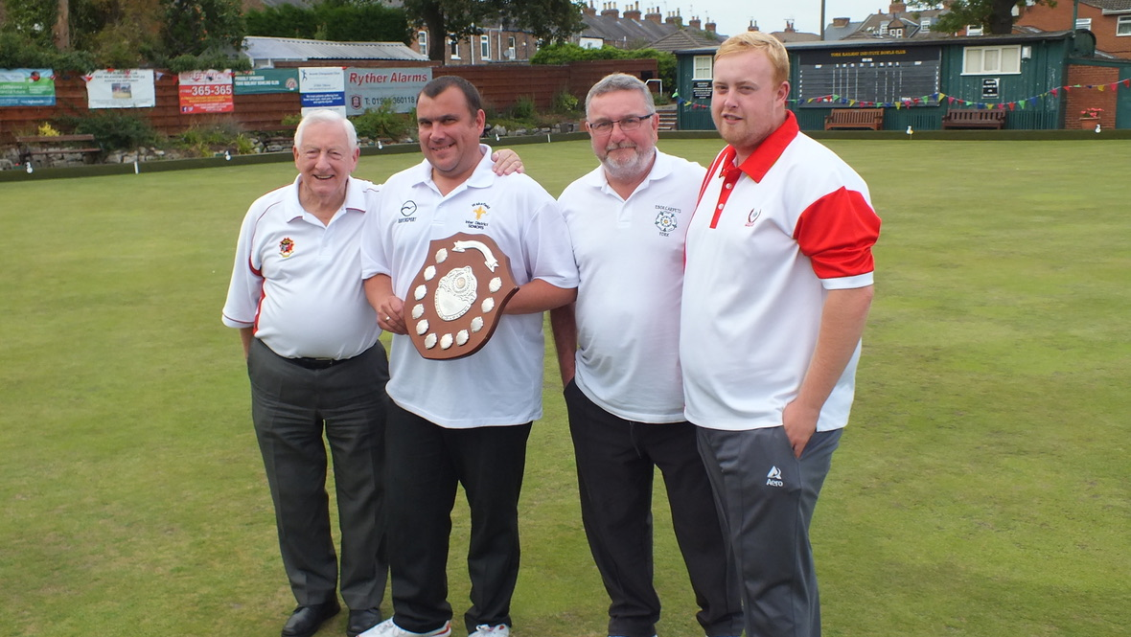

RUNNERS-UP

TOP TIPSTERS (John Crowe, Jack Woodworth, Brian Birch)

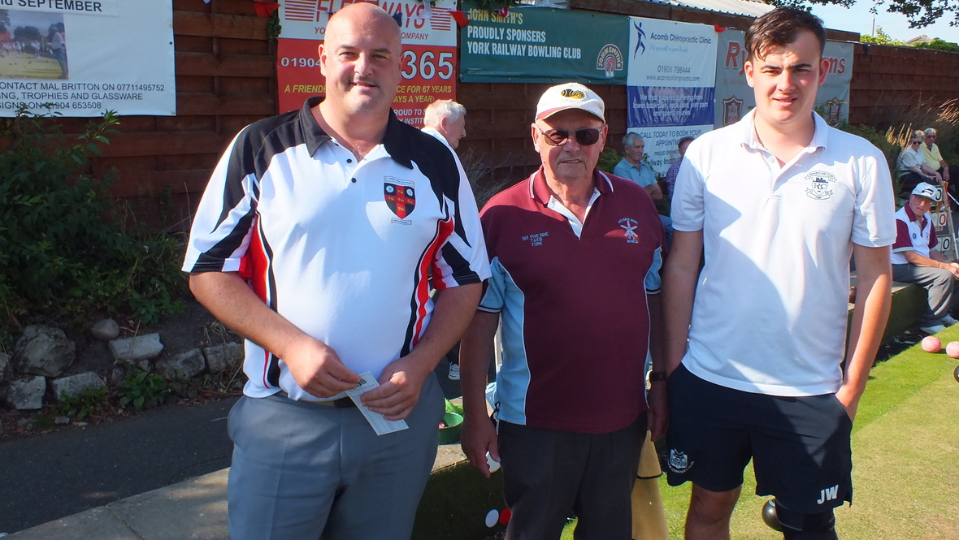
PLATE COMPETITION

WINNERS

THE THREE P’S (Pat Flannery, Pete Godwin, Pete Riley)

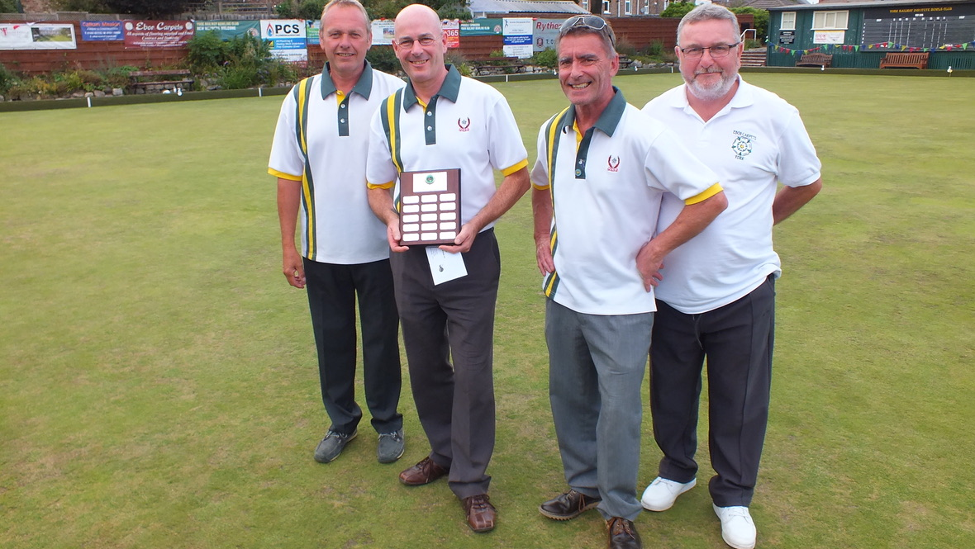

RUNNERS-UP

HOLGATE HUSTLERS (Alan Phillips, Dale Phillips, Andy Bailey)

