YORK RAILWAY INSTITUTE BOWLING CLUB
THE ERIC WILKINSON OPEN TRIPLES
S UNDAY 23 AUGUST 2015
WINNERS
GRAHAM BELL, GARY LEWINGTON & PHIL EMMERSON
JACKO’S REJECTS
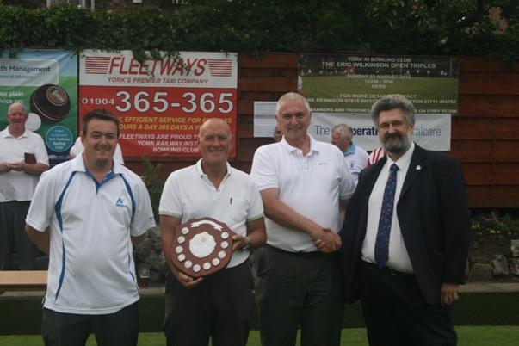
RUNNERS UP
BRIAN CHAPMAN, BILL WALDIE & DANNY MAY
SKYDIVERS
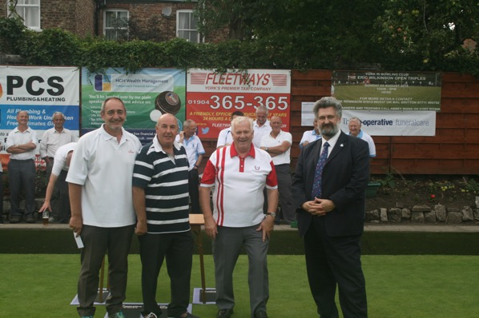

PLATE COMPETITION WINNERS
RON KEELER, MAL JONES &
MAL BRITTON (SUB ALAN PRICE)
THE EALING CONS
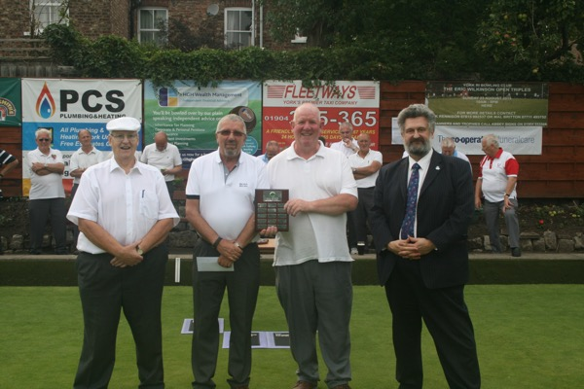

PLATE COMPETITION RUNNERS UP
JANE BENSON, SUE KIRKPATRICK & CHRISTINE GUY
INCREDIBOWLS
